***Scout P2E Game***

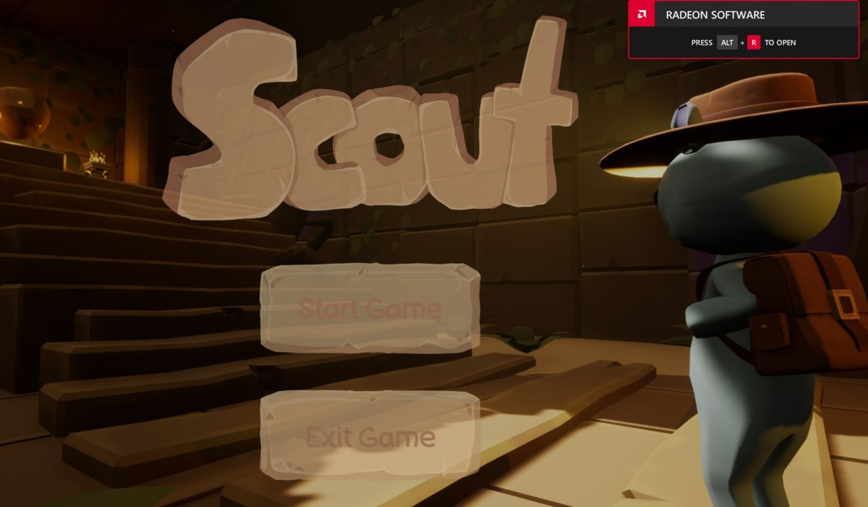

Scout is an innovative project that is being developed through ***Web3 technology*** by relying on the Binance Blockchain i.e. the Binance Smart Chain.

What is the Binance Smart Chain?

Binance Smart Chain, abbreviated as BSC, is a blockchain network of the Chinese trading platform Binance. This network is particularly suitable for running smart contract-based applications.

The choice to develop our project on this particular Blockchain is due to both the speed of individual transactions but also the very low fees.

**Given the low fees it gives everyone the opportunity to be able to invest in our project** without being able to be intimidated by high transaction fees.

Our team consists of members who individually have managed to make really good numbers in this world.

We have:

- **One of the best smart contract developers** who will go and use the innovative features brought by the Safemoon contract but going and improving them to homologate it to the mallet with our needs.

- **An excellent graphic designer** who will take care of all the banners for sponsors both on telegram and on the major sites.

- **Two heads of marketing** who will develop marketing both focused on telegram through the more classic posts, ama, etc... and outside of telegram; marketing campaigns will be carried out on the major social networks: facebok, instagram, tik tok, twitter, weibo, all accompanied by banners, pop ups and more on sites dedicated to the crypto world.

- **One web developer** who will be in charge of developing, maintaining and updating the website.

- **Two game devs** who will handle the development and integration of the game into the web3 with the help of the developer mentioned above.

How can I play **Scout**? How can I make money from it?

Playing Scout will be very simple since the team will release the finished and ready to use game through a simple link.

You will just have to open the game and decide whether to play offline or online and earn money by playing.

Both offline and online the game will be the same but unlike online you will have to link your wallet in order to start earning.

How to **earn money**.

Scout is an adventure game where you impersonate Scout, the main character of the game.

Scout is a young adventurer who, because of his heart, finds himself exploring a temple only to get stuck there.

Your goal will be to solve all the puzzles and collect the gold coins.

**Once you have collected all the coins in each level** (each puzzle is a level) you can collect your prize directly into your wallet by clicking the claim button at the end of each level.

Each level will give you the opportunity to be able to earn as much as $50 in tokens.

However, this has a limit; **you cannot earn more than $100 per day.**

This was chosen to prevent strong dumps on the graph.

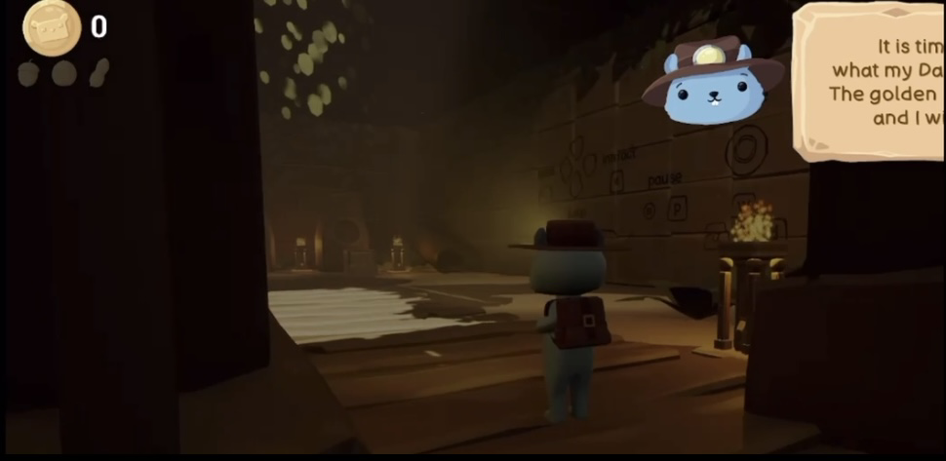

How will the project be **managed**?

**Management** and continued development will be done through an initial private sale of about 100 bnb and then continue with a presale fairlaunch and finally **launch on pancake swaps.**

The choice to work this way is not accidental, the private sale is to: fund the game development, fund the marketing and to hold up the P2E of the game.

The presale fairlaunch was chosen so as not to limit investors who decide they want to take part in the project with **higher amounts.**

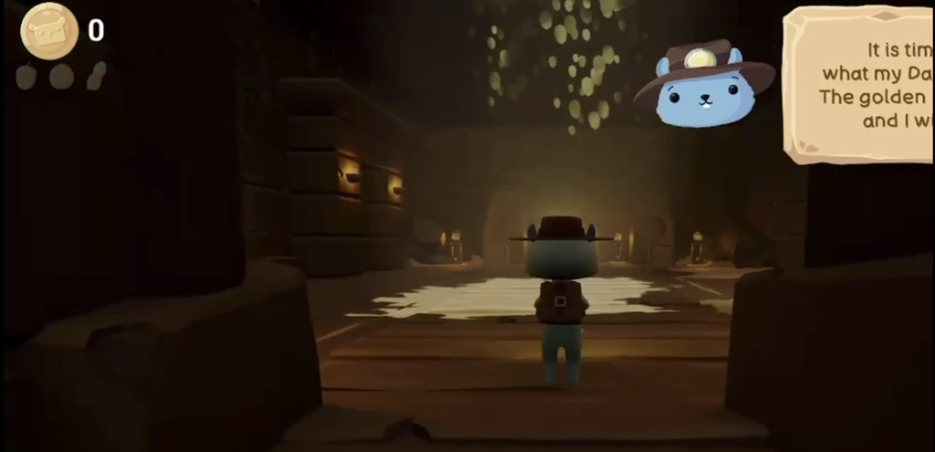

**The tokenomics will be only 1,000,000 supply, divided into:**

110,000 tokens in private sale

100,000 tokens in the presale fairlaunch

100,000 tokens in liquidity

400,000 token burn

200,000 tokens for lisitng in dex and cex extra to pancake swap

100,00 tokens for P2E maintenance, will be the tokens allocated to the game.

**Contract fees will be:**

12% Buy, divided into:

1% lp

8% marketing and development

3% Bnb rewards

12% Sell, divided into:

1% lp

8% marketing and development

3% Bnb rewards

**The choice of giving Rewards is not random** but was also chosen to make holders loyal and entice them to stay and support our project.

We also have **created a collection of NFTs**, these **NFTs** as well as being able to collect and exchange them in the market will also have a role within the game. Whoever holds 1 or more **NFTs** will receive an increase in earnable tokens based on the rarity of his **NFTs**.

**ROAD MAP:**

**Q1**

Website development and release.

**P2E game development**.

Whitepaper development and release

First phase of marketing.

Private Sale opening.

**Q2**

Continuation of marketing Closing of the private sale.

Opening of the presale fairlaunch.

Release of **sneak peek of the game with images and videos.**

Creation of an initial community.

**Q3**

Closing of the presale fairlaunch.

Launch and listing on Pancake Swap.

Release of the game.

Continued marketing.

**Request for listing on CMC and CG.**

**Q4**

Continued development of the game with new levels.

Continued marketing to get the word out about the project.

Giveaway with the community to keep it active.

**Listings** on: Bitmart, Bitpanda, Huobi, Gate.io, XT.com

Having accomplished these listings then you will aspire to the major listings, first of the chart only and then of the project on: Binance, Crypto.Com, Coinsbit and many others.